Pre-requisite - Fundamentals of Testing and Python Programming

Stage 1 - Robot Framework (Standard libraries)
Stage 2 - Robot Framework (External Libraries) - Web Automation (Selenium), API Automation (Request), Database Libraries, AutoIT Library, RPA PDF, JSON, DataDriver CSV, EXCEL, KUBELIbrary
Stage 3 - Customized Framework (Data Driven Framework, Robot Framework feature, Page Object Model, Config)
Stage 4 - Git and Jenkins

Git
Selenium/API/DB/AutoIT/PDF/JSON - https://github.com/balaji-githubstore/robot-framework-selenium-ericsson-mar-2026.git

Framework
Branch: master
Branch: b1-no-page-object
https://github.com/balaji-githubstore/robot-automation-framework-ericsson-mar-2026.git

Robot Framework
- Installation
  - Python
  - Add to the environment PATH variable
C:\Program Files\Python314
C:\Program Files\Python314\Scripts

In case any installation is done without admin mode, add the below path also
C:\Users\balaji\AppData\Roaming\Python\Python314\Scripts

  - Verify in the command prompt
python –version
  - Install Robot Framework
pip install robotframework
  - Verify
robot -–version
  - Install the IDE
    - Pycharm
      - Plugin → robotframework language server
    - VSCode
      - Plugin → robotframework

- Create a project in PyCharm
- Python Basics
  - Datatypes
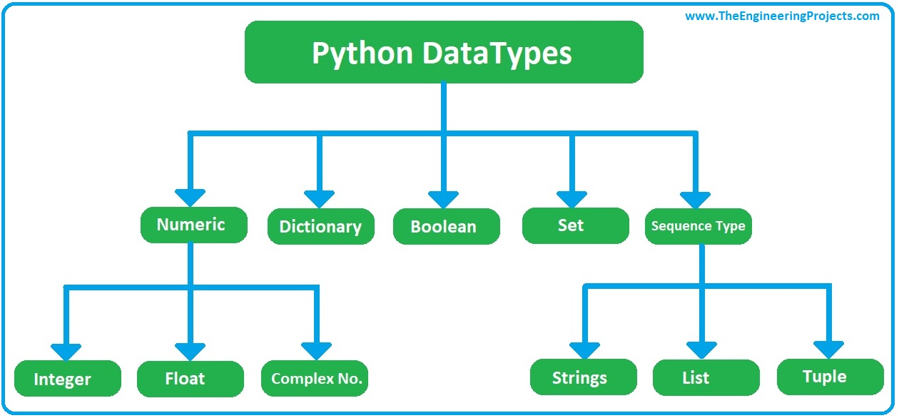

- Robot Framework Structure

Project
Robot Suite folder
Robot suite file (.robot)
- Settings
- TestCases
- Variable
- Keywords

- Robot Framework (Standard libraries)
  - Builtin - https://robotframework.org/robotframework/latest/libraries/BuiltIn.html
  - Datetime
  - String
  - Collections
  - OperatingSystem
  - Process
- Variable
  - Scalar variable ($)
  - List (@)
  - Dictionary (&)
- External libraries
  - Selenium Library (Web UI automation)
  - Request Library (Rest API Automation)
  - Database Library (DB Automation)

Selenium Library (Web UI automation)
- Install
pip install robotframework-seleniumlibrary
- Robot framework architecture

Test data → Robot Framework (.robot) → Test libraries → system under test
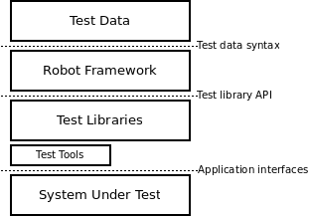

- Browser Launch
- To inspect → tagname, attribute, text or not
- Click, type, Select
- Basic locators
  - id
  - name
  - classname
  - tagname
  - Link text
  - Partial link text
When there are duplicate locators, find_element picks the first web element

- Advance locators
  - Xpath
  - CSS
- Page load - wait for page load complete
- find_element (Get WebElement)
Element should be present within 0.5s (500 ms)
- Click - element should be present and visible

- Synchronization
  - Unconditional wait
Sleep 5s → (not recommended) -> wait for given time
  - Conditional wait (from selenium lib)
    - Implicit wait
      - Default implicit wait - 0s
      - Applicable for all find_element (Get WebElement) and find_elements (Get_Webelements)
      - Example: Implicit wait - 30s
        - If the element is not present, it will check for 30 seconds and then throw an exception
        - If the element is present, it will proceed with the operation immediately
        - Polling time - 0.5s (how frequently it checks for the element)
    - Explicit wait
      - Exact wait
- Dropdown
  - With the select tag
    - Select from the list by label
    - Select from the list by value
    - Select from list by index → starts at 0
  - Without the select tag
    - Click Element
- Multiple tabs/windows, frame, alert
  - Switch window
    - Using Title
    - Using NEW and MAIN

- To inspect → f12 or ctrl+shift+c
- Alert
  - Javascript alert

- Frame - HTML embedded into another HTML
  - Even though the locator is correct, we get no such element/ no locator found error
  - Check for tagname - frame or iframe
  - Switch to that frame
    - Using xpath

- Upload
  - Check for //input[@type='file']
- CSS selector
- Actions

- Javascript
  - Click on hidden elements
  - Type on readonly textbox
  - Handle shadowroot element

Option 1: Complete JavaScript - click & type

document.querySelector('#authUser').click()
document.querySelector('#authUser').value='10 Apr 2026'

Option 2: JavaScript with find_element(GetWebElement) - click & type

arguments[0].click()

API Automation

- Basics of API testing with Postman
  - Any request → BaseUrl+Resource
  - Get Request → work on path parameter and query parameter
  - Post request
  - Put request
  - Delete request
- Get Request Find Pet By Id → Path parameter
- Get Request Find pet By Status → Query parameter
- Post Request → Add a pet to the store
- Put request
- Delete

DataBase Library

- Install
pip install robotframework-databaselibrary
pip install PyMySQL
- Row count check
  - Row count
  - Check Row Count
- Insert, Update, Delete
  - Execute SQL String
- Select
  - Query

AutoIT Library
https://github.com/nokia/robotframework-autoitlibrary

RPAFramework - <3.14

Pip install rpaframework
Pdf, word, excel, json

JSon - https://rpaframework.org/libdoc/RPA_JSON.html#library-documentation-top

Framework from scratch:

Hybrid Framework
- Robot Framework
- Data Driven Framework - separating the test case and test data in multiple files
- Page Object model - For handling web ui elements
- Customized Keyword Driven Framework for handling the Selenium library.

Steps to create a framework:

- Create project
- Configure python interpreter
- Set up the Resource folder
- Set up the Configuration folder with timeout yaml
- Install
  - pip install pyyaml
- Update requirement.txt
pip freeze > requirement.txt

To install all the libraries in requirement.txt
pip install -r requirement.txt

- Create TestSuites and Web UITestSuite
- Create a robot suite (.robot) and add a test case
- Every test case should have at least one assertion. Assertion decides whether the test case passes or fails

- Data Driven Framework - [Test Template]
  - Create a keyword (template) with proper arguments
  - Register the keyword as a test template at the setting level or test case level
  - Create a testcase and use the template
- Data Drive for CSV/Excel
  - Install
pip install robotframework-datadriver
pip install robotframework-datadriver[XLS]

  - Declare the DataDriver library along with the files

Library DataDriver file=../../../Data/LoginSuiteData/invalid_login_data.csv

  - Make sure the arguments from the template are present as a header in the CSV
${username};${password};${expected_error}
kim;kim123;Invalid credentials
wick;wick123;Invalid credentials

- Data Drive for Excel
- Control project in command line
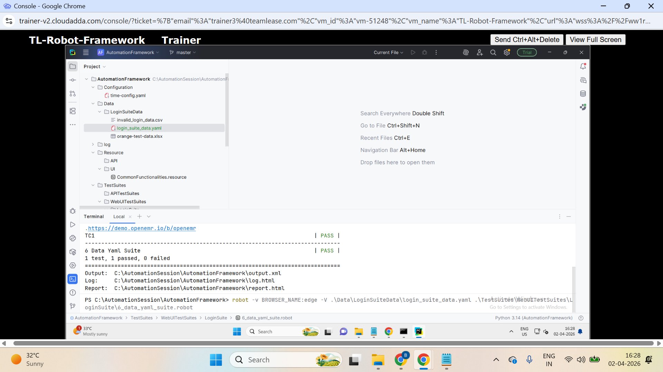

- Page Object Model
  - Reusability
  - Maintenance
  - Readability
To implement it
- Create a resource file for each web page in the application - Page class
- Operation happens through the keywords - Page methods
- Keep the object repository (locators) in the variable section

15. Libdoc html

GIT - Open Source - distributed version control system

Project (in local machine) → local repo (in local machine) → remote repo (GitHub or Bitbucket)

Local repo:
git init - initalize the local repo in the project home directory

git add. - add the files required to be committed
git commit -m "first commit" - update the local repo

Updating the remote repo

git remote add origin https://github.com/balaji-githubstore/demo-mar-2026.git - register the remote url with name
git push -u origin master - update remote repo from local repo

Jenkins
- Login to jenkins
- Create new item (free style project)
- Configure Source Code Management
- Configure Triggers
- Build Steps
  - robot -t TC1 demo3_selenium_suite\demo1_basic_suite.robot
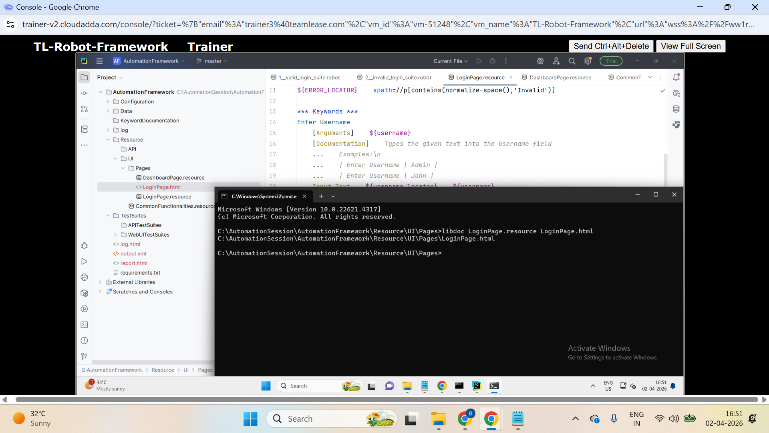

Reference
- NoSuchElement Exception - No locator found - (locator is wrong or frame)
- ElementClickIntercepted - Element is present, but some pop-up hides the target element
- ElementNotInteractable - Element is present but not visible

Day 1

Task 1
1. Navigate onto https://www.medibuddy.in/
2. Close if any popup and Click on Login
3. Click on I have Corporate Account
4. Click on Learn More
5. Click on Skip
6. Click on Login using Username & Password
7. Enter username as john
8. Enter password as john123
9. Click on show password
10. Click log in
11. Get the error message shown and print it in terminal

Task 2
1. Navigate onto https://nasscom.in/
2. Click on Login and then click on register
3. Enter First name as admin
4. Enter Last name as pass
5. Enter email address as admin@gmail.com
6. Enter company name as Google
7. Select IT Consulting from dropdown
8. No need to automate CAPTCHA
9. Click on Register

Day 2

Task 1 (Important-frame)
1. Navigate onto http://demo.openemr.io/b/openemr/
2. Update username as admin
3. Update password as pass
4. Select language as English (Indian)
5. Click on the login button
6. Click on Patient Click New Search
7. Add the first name, last name
8. Update DOB as today's date
driver.findElement(By.id("form_DOB")).sendKeys("2024-01-12");
9. Update the gender
10. . Click on the create new patient button above the form
11. . Click on confirm create new patient button.
12. . Print the text from alert box (if any error before handling alert add 5 sec wait)
13. . Handle alert
14. Close the Happy Birthday popup
15. Get the added patient name and print in the console.

Task 2 (Important-Mutliple tabs)
1. Navigate to https://www.online.citibank.co.in/
2. Close if any pop-up comes
3. Click/Mouse over on My Account
4. Click on Banking with Citi
5. Enter User id as john
6. Click on submit
7. Validate the error - Enter a valid password

Task 3 (multiple tabs)
1. Navigate to https://secure1.inmotionhosting.com/index/login
2. Click on visit our support center
3. Click on “No Thanks” if any popup
4. Search for “diskspace”
5. Get the text “Search Results for: diskspace” and print it

Git API Task
https://docs.github.com/en/rest/repos/repos?apiVersion=2026-03-10#create-a-repository-for-the-authenticated-user

